**COSE221: Digital Logic Design**

**Design Lab #2**

2022320033 Jonghyuk Park

(a) Captured waveforms of each design

<Test 1>

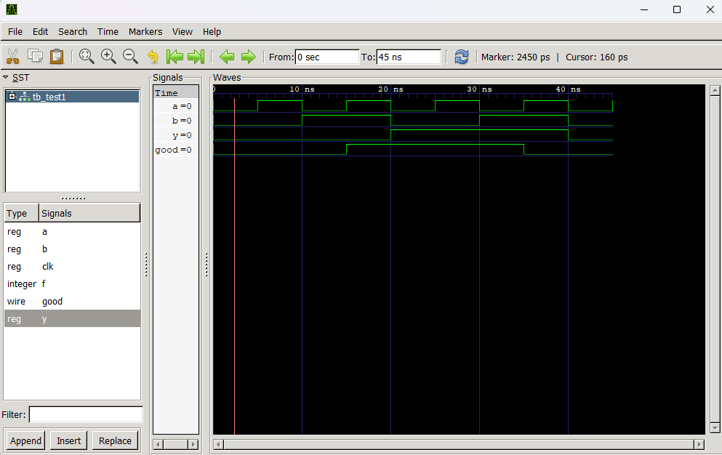

<Test 2>

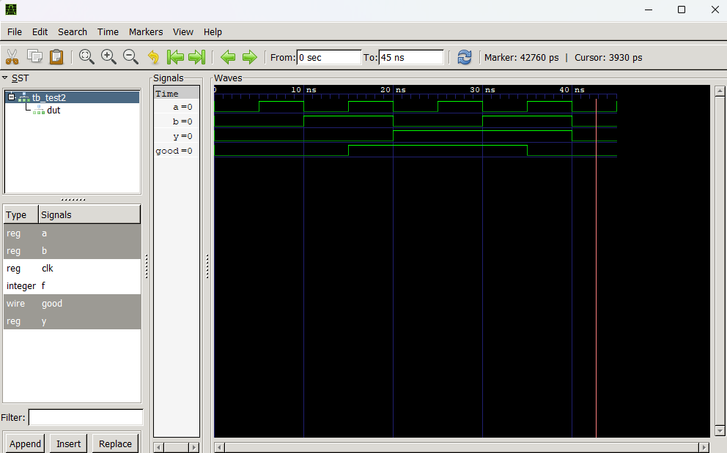

<Test 3>

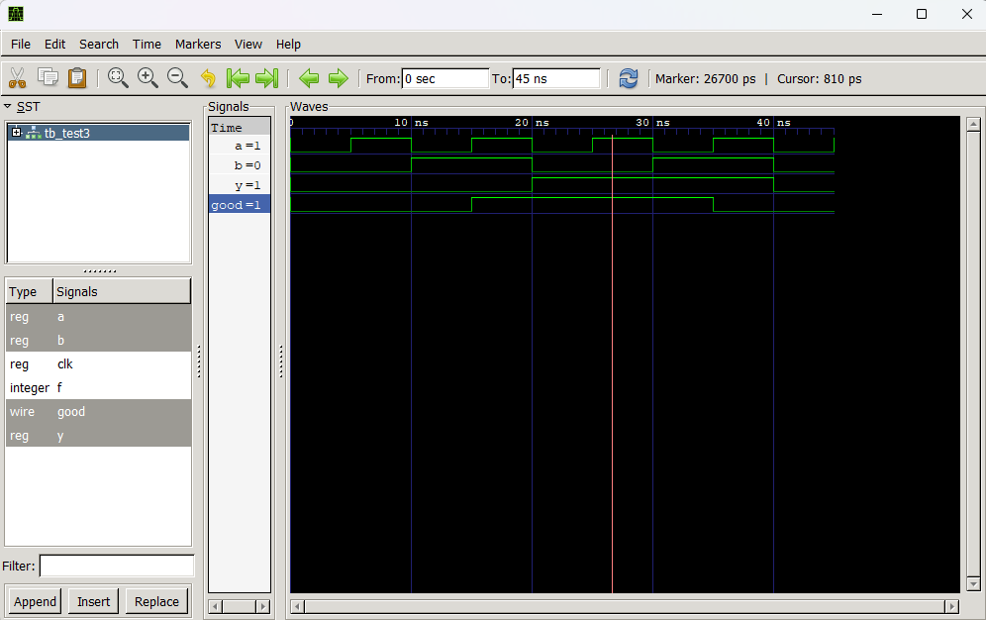

<Test 4>

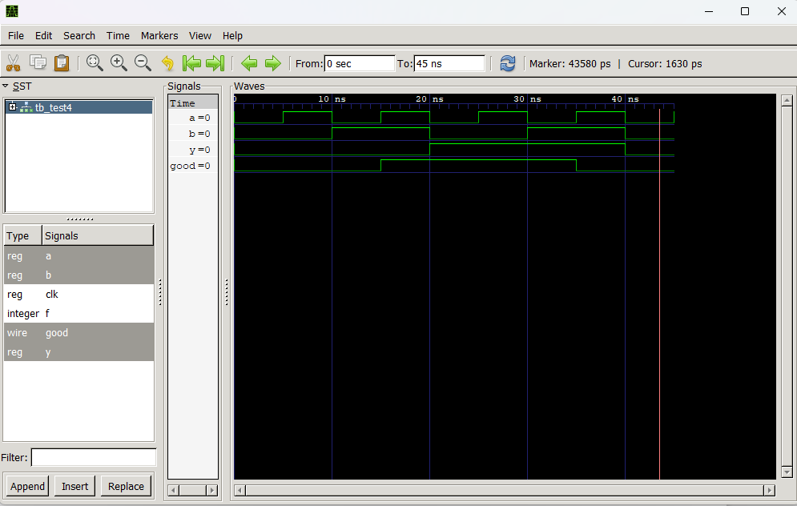

(b) Figure out the basic logic gate in the BLACKBOX module.

The output signal GOOD becomes ‘1’ when the logic gate in the BLACKBOX works correctly, so we only need to consider the case in which GOOD = 1. The truth table of signal A, B and Y is like the following, given the signal GOOD is ‘1’:

|  |  |  |
| --- | --- | --- |
| A | B | Y |
| 0 | 0 | 1 |
| 0 | 1 | 1 |
| 1 | 0 | 1 |
| 1 | 1 | 0 |

According to the truth table, the output signal Y becomes ‘0’ only if A and B are both ‘1’. Hence, the basic logic gate in the BLACKBOX module is NAND gate.